COLLECTION CREATION:

Click on Collections.

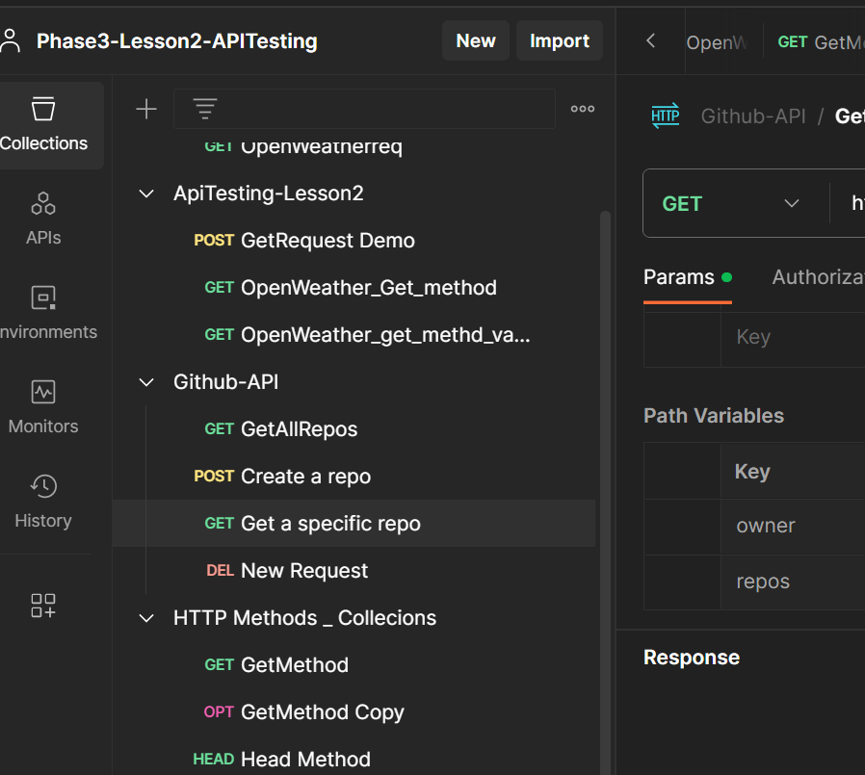

Click on “ + “ symbol to create blank Collection.

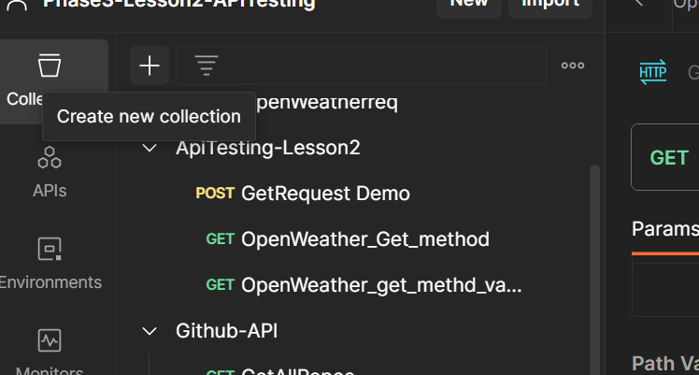

Now Name it and Give the parameters , tests ,variables to run the collection.

